## The Meridians - General Overview

[**Lung Meridian**](http://www.natural-health-zone.com/lung-meridian.html) (yin) 3am - 5am

Respiratory diseases, sore throat, cough, common cold, pain in the shoulder and along the meridian

↓ [**Large Intestine Meridian**](http://www.natural-health-zone.com/large-intestine-meridian.html) (yang) 5am - 7am

Abdominal pain, constipation, diarrhea, sore throat, toothache in the lower gum, nasal discharge and bleeding, pain along the course of the meridian

↓ [**Stomach Meridian**](http://www.natural-health-zone.com/stomach-meridian.html) (yang) 7am - 9am

Stomach problems, abdominal pain, distension, edema, vomiting, sore throat, facial paralysis, upper gum toothache, nose bleeding, pain along the meridian

↑ [**Spleen Meridian**](http://www.natural-health-zone.com/spleen-meridian.html) (yin) 9am - 11am

Problems of the spleen and pancreas, abdominal distension, jaundice, general weakness and sluggishness, tongue problems, vomiting, pain and swellings along the course of the meridian  
  
↑ [**Heart Meridian**](http://www.natural-health-zone.com/heart-meridian.html) (yin) 11am - 1pm (13:00)

Heart problems, dryness of the throat, jaundice, pain along the course of the meridian

↓ [**Small Intestine Meridian**](http://www.natural-health-zone.com/small-intestine-meridian.html) (yang) 1pm - 3pm (15:00)

Pain in the lower abdomen, sore throat, swelling or paralysis of face, deafness, pain along the meridian

↓ [**Bladder Meridian**](http://www.natural-health-zone.com/bladder-meridian.html) (yang) 3pm - 5pm (17:00)

Bladder problems, headache, eye diseases, neck and back problems, pain along the back of the leg

↑ [**Kidney Meridian**](http://www.natural-health-zone.com/kidney-meridian.html) (yin) 5pm - 7pm (19:00)

Kidney problems, lung problems, dry tongue, lumbago, edema, constipation, diarrhea, pain and weakness along the course of the meridian

↑ [**Pericardium Meridian**](http://www.natural-health-zone.com/pericardium-meridian.html) (yin) 7pm - 9pm (21:00)

Poor circulation, angina, palpitation, diseases of the sexual glands and organs, irritability, pain along the course of the meridian

﻿↓ [**Triple Warmer Meridian**](http://www.natural-health-zone.com/triple-warmer-meridian.html) - Gland Meridian (yang) 9pm - 11pm (23:00)

Diseases of the thyroid and adrenal glands, ear problems, sore throat, abdominal distension, edema, swelling of cheek, pain along the meridian

↓ [**Gallbladder Meridian**](http://www.natural-health-zone.com/gallbladder-meridian.html) (yang) 11pm - 1am

Gall bladder problems, ear diseases, migraine, hip problems, dizziness, pain along the meridian﻿﻿

↑ [**Liver Meridian**](http://www.natural-health-zone.com/liver-meridian.html) (yin) 1am - 3am

Liver problems, lumbago, vomiting, hernia, urination problems, pain in the lower abdomen and along the course of the meridian

↑

[**Governing Vessel**](http://www.natural-health-zone.com/governing-vessel.html)

Spinal problems, mental disorders, fever, nose problems, headaches

[**Conception Vessel**](http://www.natural-health-zone.com/conception-vessel.html)

Diseases of the urogenital system, hernia, cough, breathing difficulties, breast problems

### Lung Meridian

Controls Breath and Energy

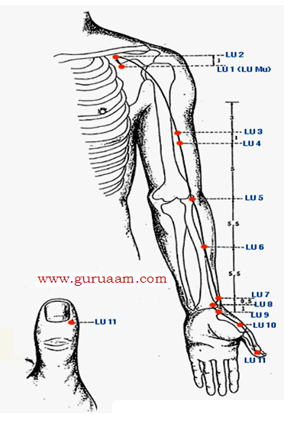

|  |  |  |
| --- | --- | --- |
| The Lung Meridian is a [yin meridian](http://www.natural-health-zone.com/yin_and_yang.html) and controls breath and energy.  It is paired with the [Large Intestine Meridian](http://www.natural-health-zone.com/large-intestine-meridian.html).  Together with the [Heart Meridian](http://www.natural-health-zone.com/heart-meridian.html) it assists with circulation of the blood. |  |  |

|  |  |
| --- | --- |
|  | Breathing also directly controls the autonomous nervous system, which is why it is basis for meditation and Chi exercises (Tai Chi, Chi Gong, Yoga, [5 Tibetans](http://www.natural-health-zone.com/five-tibetans.html)...)  Breathing hence forms a bridge between body and mind. The Lung Meridian Route This meridian begins deep in the solar plexus region ([middle burner](http://www.natural-health-zone.com/triple-warmer-meridian.html)) and descends to meet the [large intestine](http://www.natural-health-zone.com/large-intestine-meridian.html).  Winding up past the stomach, it crosses the diaphragm, divides, and enters the lungs.  It then re-unites, passes up the middle of the windpipe to the throat and divides again, surfacing in the hollow region near the front of the shoulder (LU-1). |

From here it passes over the shoulder and down the front of the arm along the outer border of the biceps muscle.

It continues down the forearm to the wrist just above the base of the thumb (LU-9). The channel crosses the height of the thumb muscle to finish at the corner of the thumbnail.

**Element:**[Metal](http://www.natural-health-zone.com/five-elements-healing.html)

**Physical Imbalances:**Disorders of the chest, lung, throat and nose﻿

**Emotional Imbalances:**

The Lungs are responsible for establishing the foundation of Qi for the entire body. The Lungs house the body's [Seven Emotions](http://www.natural-health-zone.com/7-human-emotions.html) and are responsible for self-protection and self-preservation.

Their negative attributes are disappointment, sadness, grief, despair, anxiety, shame and sorrow.

**﻿**

**When Balanced:**

Righteousness, dignity, integrity and high self-esteem**﻿**

**Peak Hours:**[3 am - 5 am](http://www.natural-health-zone.com/meridian-clock.html) **Foods:** Air... breathe!

**Large Intestine Meridian**

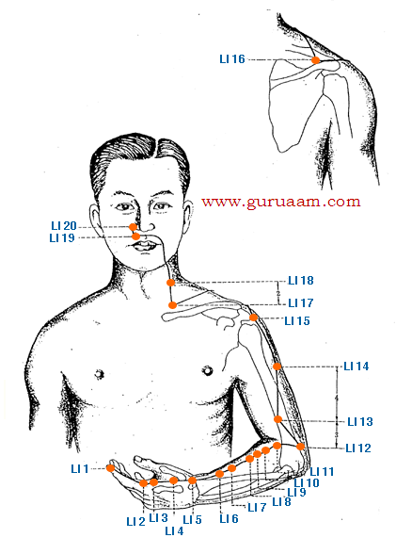

The Large Intestine Meridian is a [yang meridian](http://www.natural-health-zone.com/yin_and_yang.html) and paired with the [Lung Meridian](http://www.natural-health-zone.com/lung-meridian.html).

It controls the transformation of digestive wastes from liquid to solid state and transports the solids outwards for excretion through the rectum.

It plays a major role in the balance and purity of bodily fluids and assists the lungs in controlling the skin's pores and perspiration.

## Meridian Route

This meridian begins by the outside corner of the index fingernail.

It runs along the edge of the finger, between the two tendons of the thumb at the wrist joint and along the outer edge of the arm to the elbow.

It continues to the outside of the shoulder muscle, then crosses the shoulder blade and travels upward over the muscle at the side of the neck to the cheek, passing through the lower gums, then over the top lip.

The large intestine meridian ends beside the nostril.

**Element:**[Metal](http://www.natural-health-zone.com/five-elements-healing.html)

**Physical Imbalances:**

Paired with the lungs, the large intestine depends on the lungs for movement via the expansion  and contraction of the diaphragm, which works like a pump to give impetus to peristalsis by regulating abdominal pressure.

Sluggish bowels may be stimulated by deep diaphragmic breathing and by tonifying lung energy.

Congested lungs and clogged bronchial passages may be cleared by purging the bowels.

Symptoms of abdominal pain, intestinal cramping, diarrhea, constipation and dysentery as well as as disorders of the mouth, teeth, nose and throat.﻿

**Emotional Imbalances:**

The Large Intestine meridian is affected by the [emotions of sadness, grief, and worry](http://www.natural-health-zone.com/7-human-emotions.html).

An energetic imbalance in the Large Intestine can result in physical weakness and provoke emotional introversion, accompanied by feelings of depression, irritability, discouragement, distress and apathy and low self-esteem

**Peak Hours:**[5am-7am](http://www.natural-health-zone.com/meridian-clock.html)

# The Stomach Meridian

## Nourishment -  Physical and Emotional

|  |  |  |  |
| --- | --- | --- | --- |
| The stomach meridian is a [yang meridian](http://www.natural-health-zone.com/yin_and_yang.html) and is paired with the Spleen yin meridian.  It functions with the [Spleen Meridian](http://www.natural-health-zone.com/spleen-meridian.html) in the assimilation of Qi from food through digestion and absorption. |  |  |  |

## The Stomach Meridian Route

|  |  |
| --- | --- |
| The Spleen MeridianFor Self Esteem and Open Mindedness...The Spleen Meridian Route | The spleen meridian starts at the tip of the great toe.  From there it runs along the medial aspect of the foot at the junction of the red and white skin.  It continues up the inner leg, up across the groin, the stomach, through the diaphragm.  It connects with the [stomach](http://www.natural-health-zone.com/stomach-meridian.html) and [heart meridian](http://www.natural-health-zone.com/heart-meridian.html). Boost Your Self-esteem... This meridian is a [yin meridian](http://www.natural-health-zone.com/yin_and_yang.html) and is paired with the[stomach yang meridian.](http://www.natural-health-zone.com/stomach-meridian.html)  **Element:** [Earth element](http://www.natural-health-zone.com/five-elements-healing.html) with strong nurturing qualities.  **Physical Imbalances:**  Digestive and stomach problems.  **Emotional Imbalances:** Worry, poor concentration, forgetful-ness, cloudy thought process, addiction, attachment, obsession, gluttony, jealousy, self-pity, strong concern about opinions of others, stubbornness, low self-esteem, poor self image.  **When Balanced:** Fairness, openness, deep thinking and reminiscence, self esteem  **Peak Hours:** [9-11 am](http://www.natural-health-zone.com/meridian-clock.html) |

# The Heart Meridian - Ruler of Emotions

**Heart Meridian Route**

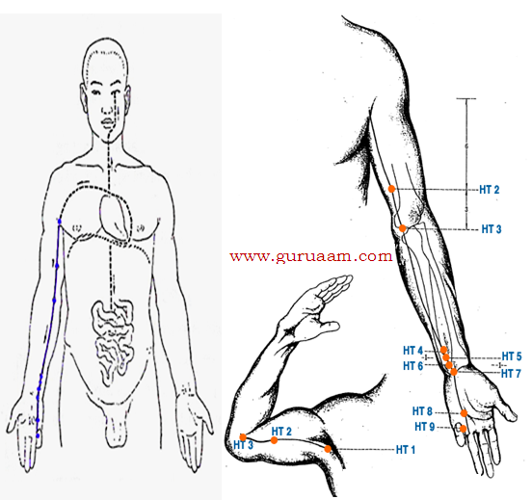

The heart meridian is a [yin meridian](http://www.natural-health-zone.com/yin_and_yang.html) and is paired with the [Small Intestine meridian](http://www.natural-health-zone.com/small-intestine-meridian.html).

It reveals itself through the brightness in the eyes, governs [Fire and Heat](http://www.natural-health-zone.com/five-elements-healing.html), rules the blood and its vessels and directs circulation - it is the[House of the Spirit](http://www.natural-health-zone.com/7-human-emotions.html).

It originates from the heart, emerges and spreads over the heart system, passes through the diaphragm to connect with the small intestine.

The exterior (surface) running part runs to the lung, then turns downward along the arm. It ends in the inner tip of the little finger.

**It rules:**blood, tongue, throat, sweat, facial complexion, adrenals, thyroid, prostate and pituitary gland.

It opens into the tongue and controls speech.

**Element:**

Belonging to the [Fire element](http://www.natural-health-zone.com/five-elements-healing.html), the Heart Meridian is associated with warmth, [laughter and enthusiasm](http://www.natural-health-zone.com/joy-in-life.html).

Just as the summer season, associated with the Fire element, brings blossoming and maturing - the flowering of all the seeds planted in the spring - love is the blossoming of the human being. It is indeed who we are in full "bloom".

Nowhere is such love felt more deeply than in the Heart.

**Physical Imbalances:**

shortness of breath, cold feeling in the chest and limbs, palpitations, cold sweat, inability to speak, memory failure and restless sleep.

**Emotional Imbalances:**

The heart is the [ruler of all emotions](http://www.natural-health-zone.com/balancing-emotions.html). Signs of imbalance include sadness, absence of laughter, depression, fear, anxiety, hysteria, erratic behavior, alternating joy and melancholy, dullness, yearning for love, jealousy and sorrow.

**When balanced:**

Tranquility, gentleness, emotional balance, spirit, love, integrity, optimism, emotional and spiritual growth, zest for life, control of thoughts and senses, conscience and wisdom.

**Peak Hours:**[11 am - 1 pm](http://www.natural-health-zone.com/meridian-clock.html)

**Chakra:**[Heart Chakra](http://www.natural-health-zone.com/chakra-colors.html)

# Small Intestine Meridian

## Sorting of the Pure and Impure...

|  |  |  |
| --- | --- | --- |
|  |  | The small intestine meridian is a [yang meridian](http://www.natural-health-zone.com/yin_and_yang.html) and is paired with the [heart yin meridian.](http://www.natural-health-zone.com/heart-meridian.html)  It receives and transforms food by separating the **Pure** from the **Impure**, with the Pure becoming bodily fluids and the Impure becoming urine - this function also operates on emotional, mental and spiritual levels.  This meridian is responsible for digestion, water absorption, nutrient absorption and bowel functions. |

## The Small Intestine Meridian Route

The Small Intestine Meridian starts from the tip of the little finger and crosses the wrist. It runs upwards along the posterior side of the forearm until it reaches the back of shoulder where it ends at the uppermost part of the back (the bottom of the neck). At this position, it travels externally across the neck and cheek until it reaches the outer corner of the eye and then ends in the ear.

**Element:**[Fire](http://www.natural-health-zone.com/five-elements-healing.html)

**Physical Imbalances:**  
Signs include bluish lips with white border, emaciation, profuse sweating, swellings of nodules, hemicrania, tinnitus, pain around the ear, and pain depressing the abdomen.

**Emotional Imbalances:**  
A feeling of mental deficiency due to inability to assimilate ideas, and insecurity. Forgetfulness, indecision, unclear thought process. Restlessness and difficulty in expressing emotions.

**When Balanced:**  
Healthy expressions are love, joy, warmth, vitality, excitement, memory, ability in making decisions, clarity of thought.

**Peak Hours:**[1-3 pm](http://www.natural-health-zone.com/meridian-clock.html)  
  
**Chakra:**[Root Chakra - Base Chakra](http://www.natural-health-zone.com/chakra-colors.html)

**Foods:**   
[Root Vegetables such as turnips and celery. Bitter greens (spinach, kale...).](http://www.natural-health-zone.com/healthy-diets.html)

# The Bladder Meridian

## Guardian of Peace

## Bladder Meridian - Flow

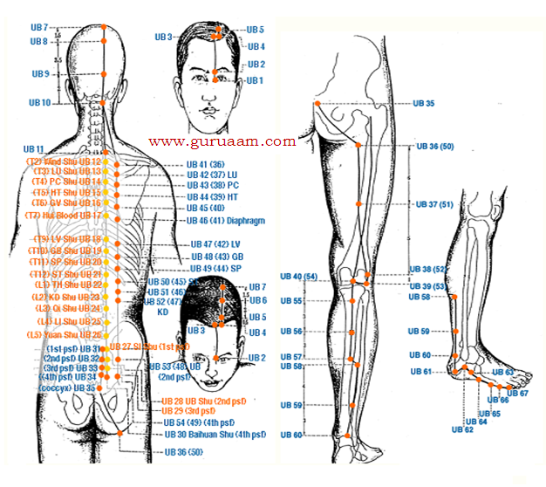  
The Bladder Meridian is a [Yang](http://www.natural-health-zone.com/yin_and_yang.html) Meridian and is paired with the Yin [Kidney Meridian](http://www.natural-health-zone.com/kidney-meridian.html).

This meridian is the longest and most complex meridian.

It starts at the inner portion of the eyelid and travels across the front of the head to the back of the head.

It then forms two branches that travel down the back to the sacrum along the spine. It then goes along the middle of the butt, and then to the back of the thigh.

The two branches then meet behind the knee and travel between the calf along the Achilles tendon to the outside of the foot.

The Bladder Meridian ends at the outside of the baby toe.

**Element:** [Water element](http://www.natural-health-zone.com/five-elements-healing.html)

**Physical Imbalances:**

headaches, back problems, or urinary problems including excessive urination and incontinence, pain in the eyes, tearing and colds. See also: [7 Emotions](http://www.natural-health-zone.com/7-human-emotions.html)

**Emotional Imbalances:**

Lack of energy, being inflexible and fearful - Resisting change and basic negative attitude are also expressions of Bladder Meridian imbalance.

**When Balanced:**Hopeful, looking forward, [calm and peaceful](http://www.natural-health-zone.com/balancing-emotions.html)

**Peak Hours:**[3 pm -5 pm](http://www.natural-health-zone.com/meridian-clock.html)

**Foods:**[Water](http://www.natural-health-zone.com/benefits-of-drinking-water.html)

**Kidney Meridian**

The kidney meridian is a [yin meridian](http://www.natural-health-zone.com/yin_and_yang.html) (flows upwards), controls the growth and development of bones and nourishes the marrow, which is the body's source of red and white blood cells.

A weak kidney is therefore a prime cause of anemia and immune deficiency.

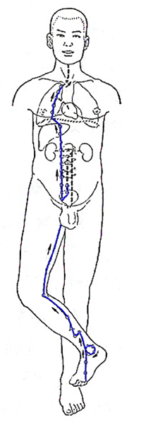 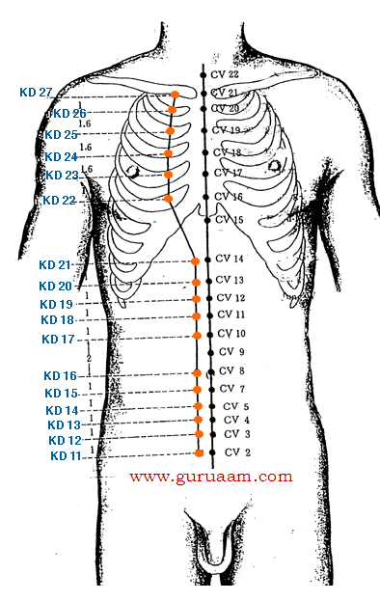

In traditional Chinese medicine, the spinal cord and the brain are forms of marrow, and therefore poor memory, inability to think clearly, and backache are all regarded as indicators of impaired kidney function and deficient kidney energy. Read also: [Kidney Cleanse](http://www.natural-health-zone.com/kidney-cleanse.html)

The Kidney meridian's vitality is reflected externally by the condition of head and body hair and is associated with the entrance hole of the ears.

Tinnitus (ringing ears) is thus a sign of kidney dysfunction.

The kidneys are the seat of courage and willpower, and therefore any impairment in kidney meridian results in feelings of fear and paranoia.

Intense fear can cause involuntary urination, a phenomenon also known to Western medicine. Read also: [7 Emotions](http://www.natural-health-zone.com/7-human-emotions.html)

The kidneys are responsible for filtering waste metabolites from the blood and moving them on-wards to the bladder for excretion in urine.

Along with the [large intestine](http://www.natural-health-zone.com/large-intestine-meridian.html), the kidneys control the balance of fluids in the body.

In addition, they regulate the body's [acid-alkaline balance](http://www.natural-health-zone.com/alkaline-diet.html) (pH) by selectively filtering out or retaining various minerals. Read also: [Detox Diets](http://www.natural-health-zone.com/detox-diet.html)

**The Kidney Meridian is paired with:**[The Bladder Meridian](http://www.natural-health-zone.com/bladder-meridian.html)

**Element:**[Water](http://www.natural-health-zone.com/miracles-of-water.html)

**Physical Imbalances:**Chest pain, asthma, abdominal pain, irregular menstruation, impotence, hernia﻿

**Emotional Imbalances:**Hysteria, paranoia, depression, fear, loneliness and insecurity

**When Balanced:**Wisdom, rationality, clear perception, gentleness and self-understanding.**﻿**

**Peak Hours:**[5-7 pm](http://www.natural-health-zone.com/meridian-clock.html)

**Foods:**[Water](http://www.natural-health-zone.com/benefits-of-drinking-water.html)

Things you can do...

[Juice fasting](http://www.natural-health-zone.com/juice-fasting.html), [water fasting](http://www.natural-health-zone.com/water-fasting.html) or a [kidney cleanse](http://www.natural-health-zone.com/kidney-cleanse.html) are ways to get your kidneys back into shape...

**The Pericardium Meridian**

Guardian of the Heart

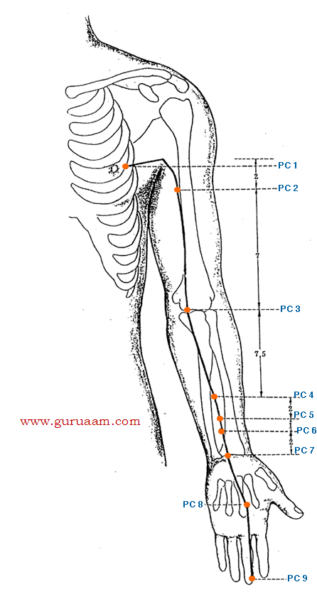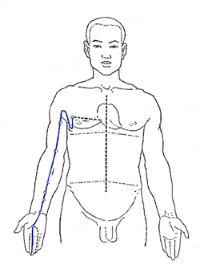

The Pericardium Meridian (also called 'Heart Constrictor' or 'Circulation-Sex' Meridian) is a [yin meridian](http://www.natural-health-zone.com/yin_and_yang.html) and is paired with the [Triple Warmer Meridian](http://www.natural-health-zone.com/triple-warmer-meridian.html) (also known as the Triple Energizer/Burner Meridian).

**The Pericardium Energy Flow**

This meridian begins in the middle of the chest, at the pericardium.

A branch descends internally through the diaphragm to the upper, middle, and lower burners - [Triple Warmer.](http://www.natural-health-zone.com/triple-warmer-meridian.html)

|  |  |
| --- | --- |
|  |  |

From the starting point a branch of the main channel crosses the chest to emerge just outside the nipple.

It then ascends on the surface around the front of the armpit and flows down the arm, through the biceps muscle.

At the elbow crease it passes just to the inside of the biceps tendon, then down the  middle of the front of the forearm, between the heart and lung channels to the wrist.

It crosses the middle of the palm to PC8 where it divides. The main channel continues to the outer corner of the middle fingernail.

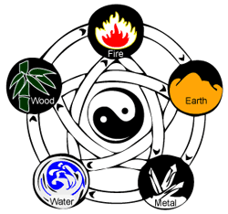

Known as the 'King's Bodyguard' (in this case... the 'king' is the heart), the pericardium meridian is the heart's protector. It is regarded as a [Fire-energy](http://www.natural-health-zone.com/five-elements-healing.html) organ.

The pericardium provides the heart with physical protection, its energy also protects the heart from damage and disruption by excessive emotional energies generated by the other organs, such as anger from the liver, fear from the kidneys, and grief from the lungs.

Extreme or long-lasting outbursts of the [Seven Emotions](http://www.natural-health-zone.com/7-human-emotions.html) disrupt energy balance and can be causes of disease. Without the pericardium to protect it, the heart would be subject to damage from the strong fluctuations in energy caused by emotional ups and downs of the day.

**The Pericardium Meridian Acu-Points**

**Paired with:**[Triple Warmer Meridian](http://www.natural-health-zone.com/triple-warmer-meridian.html)

**Element:**[Fire](http://www.natural-health-zone.com/meridian-clock.html)

**Physical Imbalances:**Disorders of the heart, chest, stomach and mind

**Emotional Imbalances:**Difficulty feeling and expressing emotions, depression, aversions, and phobias﻿

**When Balanced:**[Joy, happiness and healthy relationships﻿](http://www.natural-health-zone.com/joy-in-life.html)

**Peak Hours:**[7 pm - 9 pm](http://www.natural-health-zone.com/meridian-clock.html)

**Foods:**[Sunlight!](http://www.natural-health-zone.com/sunlight-therapy.html)

**The Triple Warmer Meridian**

Three Burners for Life Energy Transformation

The Triple Warmer Meridian (also known as Sanjiao/Triple Burner/Heater/Energizer) is a [yang meridian](http://www.natural-health-zone.com/yin_and_yang.html) and is paired with the [Pericardium Meridian](http://www.natural-health-zone.com/pericardium-meridian.html).

|  |  |  |
| --- | --- | --- |
|  |  |  |

The Triple Warmer Meridian Route

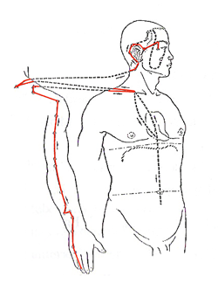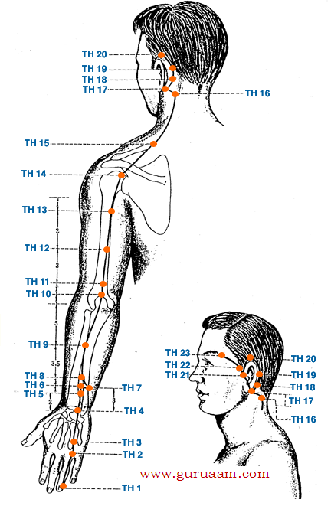

The Triple Warmer Meridian originates from the tip of the ring finger, by the outside corner of the nail, passes between the knuckles of the fourth and fifth fingers, on to the wrist.

From here it ascends between the two bones of the forearm (radius and ulna), through the tip of the elbow, and up the back of the arm to the shoulder.

It moves forward into the chest to connect with the [pericardium](http://www.natural-health-zone.com/pericardium-meridian.html), the upper burner, the abdomen and the middle and lower [burners](http://www.natural-health-zone.com/triple-warmer-meridian.html). Re-emerging from the chest at the collarbone, the meridian ascends the side of the neck and around the back of the ear.

Meridian Charts

|  |  |  |  |
| --- | --- | --- | --- |
| Element: [Fire](http://www.natural-health-zone.com/five-elements-healing.html)  Physical Imbalances: Disorders of the side of the head, ears, eyes and throat as well as diseases involving the regions through which the meridian runs ([gallbladder meridian](http://www.natural-health-zone.com/gallbladder-meridian.html),[pericardium meridian](http://www.natural-health-zone.com/pericardium-meridian.html), [small intestine meridian](http://www.natural-health-zone.com/small-intestine-meridian.html))  When balanced: Kindhearted, stable mind and emotion of joy  Peak Hours: [9 pm - 11 pm](http://www.natural-health-zone.com/meridian-clock.html)  This meridian is responsible for the movement and transformation of various solids and fluids throughout the system, as well as for the production and circulation of nourishing and protective energy.  It is a functional energy system, involved in regulating the activities of other organs, composed of three parts, known as 'burners', located in thorax, abdomen, and pelvis.  The Upper Burner controls intake, the Middle Burner controls transformation, the Lower Burner controls elimination.  One branch rises internally to meet the [gallbladder meridian](http://www.natural-health-zone.com/gallbladder-meridian.html) on the forehead, then descends to join the [small intestine meridian](http://www.natural-health-zone.com/small-intestine-meridian.html) on the cheek.  The superficial branch continues to the front of the ear and crosses to the outer corner of the eyebrow, where it again joins the gallbladder meridian.   |  |  | | --- | --- | |  |  | |  |

**The Gallbladder Meridian...**

|  |  |  |
| --- | --- | --- |
| Courage and Initiative  The Gallbladder Meridian is a [yang meridian](http://www.natural-health-zone.com/yin_and_yang.html)and is paired with the [Liver Meridian.](http://www.natural-health-zone.com/liver-meridian.html)  This Meridian's Qi (energy flow) is responsible, among other, for [decision making](http://www.natural-health-zone.com/true-meaning-of-success.html) and good judgments, as well as providing courage and initiative. |  |  |

The Gallbladder Meridian Route

|  |  |
| --- | --- |
| Gall-bladder-meridian-route - www.natural-health-zone.com | This meridian begins just outside the outer corner of the eye, turns down towards the ear and then up to the forehead just within the hair line, then descends behind the ear to the corner of the skull.  It then returns to the forehead above the center of the eye and moves down the head to the bottom of the skull.  It continues down the neck to the shoulder, descends the side of the body along the ribs, to the waist and pelvic. It continues down the outside of the leg, to the ankle, ending on the outside of the 4th toe.  **Gallbladder Meridian Element:** [Wood](http://www.natural-health-zone.com/five-elements-healing.html) |

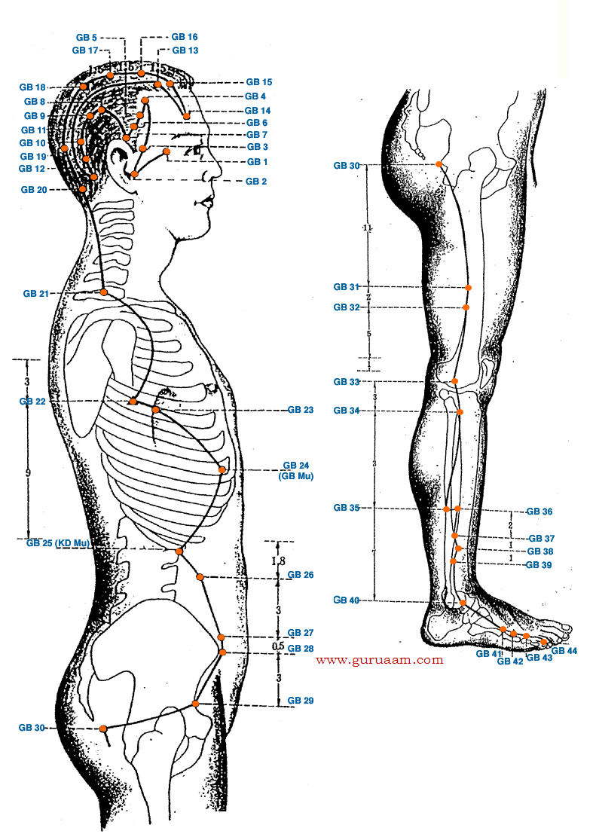

**Physical Imbalances:**insomnia - waking up suddenly, very early in the morning and not being able to fall asleep again, tendons, tears, nails, eye diseases, glaucoma, and night blindness, stiff neck, ringing in the ears, dizziness

**Emotional Imbalances:** timidity, indecision, easily discouraged... and resentment.

﻿**When Balanced:**courage and initiative, decision making and good judgment, sound sleep, healthy expression and processes of creativity, planning, brainstorming, analysis, and decision-making

**Peak Hours:**[11pm - 1am](http://www.natural-health-zone.com/meridian-clock.html)

**Gallbladder Meridian Foods:**'Woody foods' - leafy greens, grains... A great habit to take on, is having a [green smoothie](http://www.natural-health-zone.com/raw-food-diet.html) (leafy greens + other veggies - juiced or blended) a day! Works wonders!

|  |  |
| --- | --- |
| **The Liver Meridian**  The Liver Meridian Replenishment of the Blood for Growth and Renewal  The Liver Meridian is a [yin meridian](http://www.natural-health-zone.com/yin_and_yang.html) paired with the [Gallbladder Meridian](http://www.natural-health-zone.com/gallbladder-meridian.html).  It is responsible for filtering, [detoxifying](http://www.natural-health-zone.com/detox-diet.html),[nourishing](http://www.natural-health-zone.com/healthy-diets.html), replenishing, and storing blood.  It regulates the amount of blood circulating, withdrawing and storing it when resting or sleeping, and releasing it during exercise. ﻿ |  |

|  |  |
| --- | --- |
|  | Meridian Route  The Liver Meridian starts inside of the big toenail, crosses the top of the foot, passes in front of the inside ankle and up the inner aspect of the leg.  It continues upwards, passes the knee, continues along the inner thigh to the groin and pubic region, where it circulates the external genitals.  It connects with the [conception vessel](http://www.natural-health-zone.com/conception-vessel.html) in the lower abdomen and further up enters both the liver and gallbladder.  The meridian then dips into the rib cage, runs up through the throat, opening to the eye, and ends at the crown of the head where it connects with the [governing vessel](http://www.natural-health-zone.com/governing-vessel.html). |

One meridian branch circles the mouth and another branch, from within the liver, reaches the lungs, which then restarts the cycle of Qi (Chi).

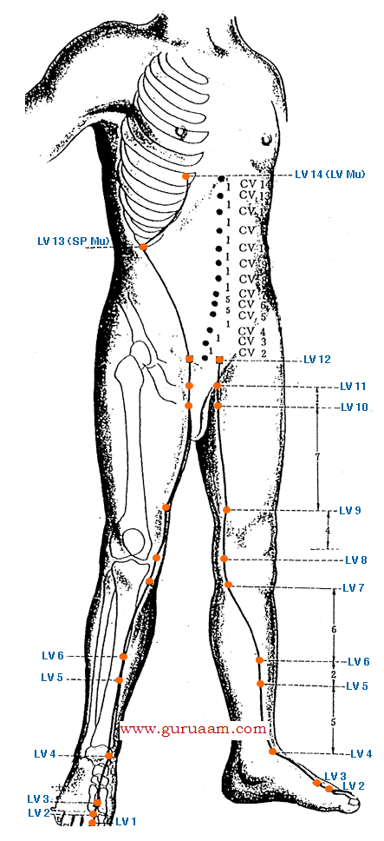

|  |  |  |
| --- | --- | --- |
| **Element:**[Wood﻿](http://www.natural-health-zone.com/five-elements-healing.html)  **Physical Imbalances:**Liver function is reflected externally in the condition of finger- and toenails and by the eyes and vision. Blurry vision is often a result of liver malfunction rather than an eye problem.  **Emotional Imbalances:**The liver governs growth and development, drive and desires, ambitions and creativity.  Obstruction of liver energy can cause [intense feelings of frustration, rage, and anger](http://www.natural-health-zone.com/7-human-emotions.html)... as well as irritability, resentment, jealousy and depression.**﻿**  **When Balanced:**Kindness, compassion, and generosity.**﻿** |  |  |

**Peak Hours:**[1am-3am](http://www.natural-health-zone.com/meridian-clock.html)

**Foods:**[Leafy Greens](http://www.natural-health-zone.com/raw-food-diet.html)... try a [liver detox](http://www.natural-health-zone.com/liver-detox.html)... or/and an all-around [detox diet](http://www.natural-health-zone.com/detox-diet.html).﻿

|  |  |  |
| --- | --- | --- |
| **Governing Vessel(GV)** 'Sea of Yang Meridians'  *”*[*The Conception vessel*](http://www.natural-health-zone.com/conception-vessel.html)*and the Governing vessel are like midnight and midday, they are the polar axis of the body ... there is one source and two branches, one goes to the front and the other to the back of the body ... When we try to divide these, we see that*[*yin and yang*](http://www.natural-health-zone.com/yin_and_yang.html)*are inseparable. When we try to see them as one, we see that it is an indivisible whole.”*  [Li Shi-zhen](http://en.wikipedia.org/wiki/Li_Shizhen)*﻿* |  |  |

The Governing Vessel Meridian Flow

The Governing and [Conception Vessels](http://www.natural-health-zone.com/conception-vessel.html) are two branches of the same source, and inseparable[Yin-and-Yang](http://www.natural-health-zone.com/yin_and_yang.html), front-and-back duality.

These vessels connect the uterus with the kidneys, heart, and brain.

Regulating the Governing and Conception Vessels is a priority in Medical Qigong practice.

Along these vessels, the Yang Fire and Yin Essence flow up and down the body, fusing the Water and Fire energies together ([Five Elements Healing](http://www.natural-health-zone.com/five-elements-healing.html)).

This fusion facilitates a Yin and Yang balance throughout the body.

|  |  |
| --- | --- |
| Govering Vessel Meridian Flow - www.natural-health-zone.com | The Governing Vessel Meridian is yang in nature and starts from the uterus, runs down to the central region of the pelvis around the genitals and into the external orifice of the urethra in women and around the penis in men.  It passes by the anus, moves upward from inside the coccyx and sacrum and enters the brain.  The external portion runs to the lower end of the nose bridge and ends at the gum.  **Governing Vessel Meridian Branches:**  * The first branch runs side by side with the[kidney meridian](http://www.natural-health-zone.com/kidney-meridian.html), enters the spine from the coccyx and sacrum region and links with the kidney. |

* The second branch runs side by side with the [bladder meridian](http://www.natural-health-zone.com/bladder-meridian.html), ascends from the corner of the eye, reaches the vertex (upper most part of the head) and links with the brain. Then it runs downward the neck beside the spine.

* The third branch arises directly from the uterus and through the umbilicus, then passes through the heart, enters the throat, comes to the mandible, runs around the lips and ends below the eyes.

Governing Vessel Meridian Acu-Points

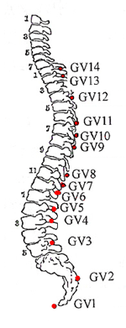

**GV1 - Changqiang -** Constipation, hemorrhoids, prolaps of rectum, depressive or manic psychosis, epilepsy, rigid and arched back, pain in the coccyx and sacrum area.

**GV2 - Yaoshu -** Stiffness and pain in the loins and spine, irregular menstruation, hemorrhoids, epilepsy.

**GV3 - Yaoyangguan -** Pain in the loins and sacral region, irregular menstruation, impotence.

**GV4 - Mingmen -** Stiffness and pain in the loins and spine, irregular menstruation, morning diarrhea,  impotence.

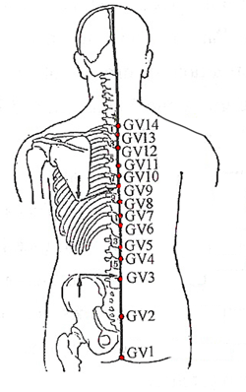

**GV5 - Xuanshu -** Local point for low back pain, diarrhea, indigestion, poor assimilation (undigested food in stools), panic attacks, abdominal pain, indigestion, hernias.

**GV6 - Jizhong -** Hemorrhoids, prolapse of the rectum, stiffnes and pain in the loins and spine, epilepsy, diarrhea, jaundice.

**GV7 - Zhongshu -** Local point for back pain. Epigastric pain, abdominal pain and/or bloating, poor appetite, amenorrhea.

**GV8 - Jinsuo -** Stiffness of spine, depression, epilepsy, stomachache, jaundice.

**GV9 - Zhiyang -** Distending pain in the chest and hypochondria, jaundice, caugh, stiffness of the spine and back.

**GV10 - Lingtai -** Cough, asthma, stiffness of spine and back.

**GV11 - Shendao -** Angina pectoris, palpitations, amnesia, insomnia, cough, asthma, stiffness of spine and back.

**GV12 - Shenzhu -**Cough, asthma, epilepsy, pain and stiffness in the spine and back.

**GV13 - Taodao -** Headache, stiff neck, stiffness of the spine, aversion to cold, fever, cough, asthma, epilepsy and malaria.

**GV14 - Dazhui -** Headache, stiffness of neck, cough, asthma, night sweating, epilepsy, febrile disease and malaria.﻿

**GV15 - Yamen -** Sudden loss of voice, headache, stiff neck depressive psychosis, epilepsy.

**GV16 - Fengfu -** Epilepsy, stiff neck, headache, dizziness, sore throat and loss of voice.

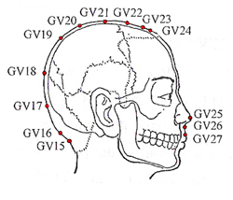

**GV17 - Naohu -** Headache, dizziness, loss of voice, stiff neck, manic and depressive psychosis.

**GV18 - Qiangjian -** Headache, vertigo, facial distortion, stiff neck, epilepsy and insomnia.

**GV19 - Houding -** Headache, vertigo, stiffness and pain in neck, manic and depressive psychosis, epilepsy and insomnia.

**GV20 - Baihui -** Headache, vertigo, wind stroke, insomnia, prolonged diarrhea.

**GV21 - Qianding -** Headache, vertigo, sinusitis, redness, swelling and pain of eyes, epilepsy.

**GV22 - Xinhui -** Headache, vertigo, sinusitis, nasal polyp, redness, swelling and pain of eyes, epilepsy.

**GV23 - Shangxing -** Nasal obstruction, sinusitis, headache, vertigo, pain of eyes, epilepsy and malaria.

**GV24 - Shenting -** Headache, vertigo, sinusitis, cataract, insomnia.

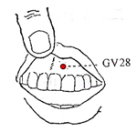

**GV25 - Suliao -** Sinusitis, nasal polyp, running nose, unconsciousness, convulsion and suffocation.

**GV26 - Shuigou -** Unconsciousness, depressive and manic psychosis, epilepsy, infantile convulsion, facial distortion, toothache, lockjaw, nasal obstruction, stiff neck.

**GV27 - Dui Duan -** Problems of the mouth and sinuses - tongue ulcers, bad breath (halitosis), pain and/or swelling of the gums, nosebleed, nasal congestion, manic depression, epilepsy.

**GV28 - Yinjiao -** Swelling and pain of the gums, oral sore, psychosis.

| **POINT** | **LOCATION** |
| --- | --- |
| [GV 1](https://theory.yinyanghouse.com/acupuncturepoints/gv1) | Midway between the tip of the coccyx bone and the anus. |
| [GV 2](https://theory.yinyanghouse.com/acupuncturepoints/gv2) | In the hiatus of the sacrum (where you feel a superior ridge where S4 & S5 bones were as a child). |
| [GV 3](https://theory.yinyanghouse.com/acupuncturepoints/gv3) | L4. |
| [GV 4](https://theory.yinyanghouse.com/acupuncturepoints/gv4) | L2. |
| [GV 5](https://theory.yinyanghouse.com/acupuncturepoints/gv5) | L1. |
| [GV 6](https://theory.yinyanghouse.com/acupuncturepoints/gv6) | T11. |
| [GV 7](https://theory.yinyanghouse.com/acupuncturepoints/gv7) | T10. |
| [GV 8](https://theory.yinyanghouse.com/acupuncturepoints/gv8) | T9. |
| [GV 9](https://theory.yinyanghouse.com/acupuncturepoints/gv9) | T7. |
| [GV 10](https://theory.yinyanghouse.com/acupuncturepoints/gv10) | T6. |
| [GV 11](https://theory.yinyanghouse.com/acupuncturepoints/gv11) | T5. |
| [GV 12](https://theory.yinyanghouse.com/acupuncturepoints/gv12) | T3. |
| [GV 13](https://theory.yinyanghouse.com/acupuncturepoints/gv13) | T1. |
| [GV 14](https://theory.yinyanghouse.com/acupuncturepoints/gv14) | C7. |
| [GV 15](https://theory.yinyanghouse.com/acupuncturepoints/gv15) | .5 cun above the midpoint of the PHL in a depression below the spinous process of C1. |
| [GV 16](https://theory.yinyanghouse.com/acupuncturepoints/gv16) | 1 cun directly above the midpoint of the PHL, directly below the occipital protuberance on the posterior midline of the head. |
| [GV 17](https://theory.yinyanghouse.com/acupuncturepoints/gv17) | Midway between [GV 16](https://theory.yinyanghouse.com/acupuncturepoints/gv16) and [GV 18](https://theory.yinyanghouse.com/acupuncturepoints/gv18). |
| [GV 18](https://theory.yinyanghouse.com/acupuncturepoints/gv18) | Midway between [GV 16](https://theory.yinyanghouse.com/acupuncturepoints/gv16) and [GV 20](https://theory.yinyanghouse.com/acupuncturepoints/gv20). |
| [GV 19](https://theory.yinyanghouse.com/acupuncturepoints/gv19) | Midway between [GV 18](https://theory.yinyanghouse.com/acupuncturepoints/gv18) and [GV 20](https://theory.yinyanghouse.com/acupuncturepoints/gv20). |
| [GV 20](https://theory.yinyanghouse.com/acupuncturepoints/gv20) | 5 cun posterior to the AHL. |
| [GV 21](https://theory.yinyanghouse.com/acupuncturepoints/gv21) | Midway between [GV 20](https://theory.yinyanghouse.com/acupuncturepoints/gv20) and [GV 22](https://theory.yinyanghouse.com/acupuncturepoints/gv22). |
| [GV 22](https://theory.yinyanghouse.com/acupuncturepoints/gv22) | 1 cun posterior to [GV 23](https://theory.yinyanghouse.com/acupuncturepoints/gv23). |
| [GV 23](https://theory.yinyanghouse.com/acupuncturepoints/gv23) | 1 cun posterior to the AHL and .5 cun posterior to [GV 24](https://theory.yinyanghouse.com/acupuncturepoints/gv24). |
| [GV 24](https://theory.yinyanghouse.com/acupuncturepoints/gv24) | Midway between the AHL and [GV 23](https://theory.yinyanghouse.com/acupuncturepoints/gv23). |
| [GV 25](https://theory.yinyanghouse.com/acupuncturepoints/gv25) | On the tip of the nose. |
| [GV 26](https://theory.yinyanghouse.com/acupuncturepoints/gv26) | At the junction of the upper and middle third of the philtrum. |
| [GV 27](https://theory.yinyanghouse.com/acupuncturepoints/gv27) | At the junction of the upper lip and the philtrum. |
| [GV 28](https://theory.yinyanghouse.com/acupuncturepoints/gv28) | At the junction of the gum and the frenulum of the upper lip. |

**Conception Vessel Meridian** –

|  |  |  |
| --- | --- | --- |
| 'Sea of Yin' The Conception vessel, or meridian, plays a major role in [Qi circulation](http://www.natural-health-zone.com/yin_and_yang.html), monitoring and directing all of the Yin channels.  It forms a circular entity with the [Governing Vessel](http://www.natural-health-zone.com/governing-vessel.html).  **Conception Vessel Flow** |  |  |

In Qigong society, the Conception Vessel and the [Governing Vessel](http://www.natural-health-zone.com/governing-vessel.html) are considered the most important among the Qi channels and vessels, and must be trained first.

Whereas the Governing meridian runs from the tailbone upwards along the mid-line of the**back** through the vertebrae to the head, this Meridian runs up the **anterior (front)** of the body, from the pubic area to the mouth.

|  |  |
| --- | --- |
| Conception Vessel Meridian Acu Points - www.natural-health-zone.com | **CV1 - Huiyin -** This Acu-point has particular and special qualities but because of its location is not much used. Other points share some of its qualities, such as CV2.  **CV2 - Qugu -** Irregular menstruation, unsmooth urination, seminal emission, impotence.  **CV3 - Zhongji -** Irregular menstruation, unsmooth urination, seminal emission, impotence, prolapse of the uterus.  **CV4 - Guanyuan -** Diarrhea, irregular menstruation, sterility, frequent urination, anuria, seminal emission, impotence, hernia.  **CV5 - Shimen -** Abdominal pain, edema, unsmooth urination, diarrhea, hernia.  **CV6 - Qihai -** Abdominal pain, edema, unsmooth urination, diarrhea, constipation, hernia. Powerful revitalising and reinvigorating point.  **CV7 - Yinjiao -** Lower back pain, knee pain, constipation, irregular menstruation, menstrual cramps, infertility. |

**CV8 - Shenque -** Abdominal pain, diarrhea, prolapse of rectum, edema and prostration.

**CV9 - Shuifen -** Abdominal pain, regurgitation, vomiting, diarrhea, anuria and edema.

**CV10 - Xiawan -** Abdominal pain and distension, dyspepsia, vomiting, diarrhea and abdominal mass. **CV11 - Jianli -** Stomachache, abdominal distension, vomiting, poor appetite and edema.

**CV12 - Zhongwan -** Stomachache, abdominal distension, vomiting, hiccup, acid regurgitation, jaundice, diarrhea, edema, anorexia, dyspepsia, depressive and manic psychosis, postpartum syndrome, insomnia and asthma.

**CV13 - Shangwan -** Stomachache, abdominal distension, vomiting and epilepy.

**CV14 - Juque -** Angina pectoris, palpitation, amnesia, vomiting, acid regurgitation, hiccup, jaundice, depressive and manic psychosis and epilepsy.

**CV15 - Juiwei -** Angina pectoris, palpitation, vomiting, cough, asthma, chest pain, abdominal distension, diarrhea, hiccup, jaundice, depressive and manic psychosis and epilepsy.

|  |  |
| --- | --- |
| Conception Vessel Meridian Acu Points - www.natural-health-zone.com | **CV16 - Zhong Ting -** Chest and intercostal distention and pain, hiccups, nausea, anorexia and difficulty ingesting.  **CV17 - Tanzhong -** Cough, asthma, chest pain, angina pectoris, palpitations, insomnia, insufficiency of lactation, vomiting.  **CV18 - Yutang -** Cough, asthma, chest pain and vomiting.  **CV19 - Zi Gong -** chest issues - pain, cough, asthma, vomiting and difficulty ingesting.  **CV20 - Hui Gai -** chest issues - pain, asthma, wheezing, cough and difficulty ingesting  **CV21 - Xuanji -** Cough, asthma, chest pain and sore throat. |

|  |  |  |
| --- | --- | --- |
| Conception Vessel Meridian Acu Points - www.natural-health-zone.com | **CV22 - Tiantu -** Cough, asthma, chest pain, sore throat, sudden loss of voice, goiter, obstructive sensation in throat.  **CV23 - Lianquan -** Sublingual swelling and pain, sluggish movement of tongue, drooling, sudden loss of voice and difficulty swallowing.  **CV24 - Chengjiang -** Facial distortion, swelling and pain of gums, drooling and epilepsy. | |
| **POINT** | **LOCATION** |
| [CV 1](https://theory.yinyanghouse.com/acupuncturepoints/cv1) | In the center of the perineum, Males: in between the anus and the scrotum, Females: between the anus and the posterior labial commissure. |
| [CV 2](https://theory.yinyanghouse.com/acupuncturepoints/cv2) | On top of the notch in the center of superior border of the pubic symphysis. |
| [CV 3](https://theory.yinyanghouse.com/acupuncturepoints/cv3) | 1 cun above CV 2 (pubic symphysis). |
| [CV 4](https://theory.yinyanghouse.com/acupuncturepoints/cv4) | 2 cun above CV 2 (pubic symphysis). |
| [CV 5](https://theory.yinyanghouse.com/acupuncturepoints/cv5) | 3 cun above CV 2 (pubic symphysis). |
| [CV 6](https://theory.yinyanghouse.com/acupuncturepoints/cv6) | Midway between CV 5 and CV 7, 1.5 cun below CV 8 (umbilicus). |
| [CV 7](https://theory.yinyanghouse.com/acupuncturepoints/cv7) | 1 cun below CV 8 (umbilicus). |
| [CV 8](https://theory.yinyanghouse.com/acupuncturepoints/cv8) | In the center of the umbilicus. |
| [CV 9](https://theory.yinyanghouse.com/acupuncturepoints/cv9) | 1 cun above CV 8 (umbilicus). |
| [CV 10](https://theory.yinyanghouse.com/acupuncturepoints/cv10) | 2 cun above CV 8 (umbilicus). |
| [CV 11](https://theory.yinyanghouse.com/acupuncturepoints/cv11) | 3 cun above CV 8 (umbilicus). |
| [CV 12](https://theory.yinyanghouse.com/acupuncturepoints/cv12) | Midway between CV 8 and CV 16, 4 cun above CV 8 (umbilicus). |
| [CV 13](https://theory.yinyanghouse.com/acupuncturepoints/cv13) | 5 cun above CV 8 (umbilicus). |
| [CV 14](https://theory.yinyanghouse.com/acupuncturepoints/cv14) | 6 cun above CV 8 (umbilicus). |
| [CV 15](https://theory.yinyanghouse.com/acupuncturepoints/cv15) | 7 cun above CV 8 (umbilicus). |
| [CV 16](https://theory.yinyanghouse.com/acupuncturepoints/cv16) | Level with the 5th ICS, where the right and left ribs meet on the lower border of the sternum at the junction of the sternum and xiphoid process. |
| [CV 17](https://theory.yinyanghouse.com/acupuncturepoints/cv17) | Level with the 4th ICS, midway between the nipples. |
| [CV 18](https://theory.yinyanghouse.com/acupuncturepoints/cv18) | Level with the 3rd ICS. |
| [CV 19](https://theory.yinyanghouse.com/acupuncturepoints/cv19) | Level with the 2nd ICS. |
| [CV 20](https://theory.yinyanghouse.com/acupuncturepoints/cv20) | Level with the 1st ICS. |
| [CV 21](https://theory.yinyanghouse.com/acupuncturepoints/cv21) | Between CV 20 and CV 22. |
| [CV 22](https://theory.yinyanghouse.com/acupuncturepoints/cv22) | At the notch in the superior aspect of the suprasternal fossa. |
| [CV 23](https://theory.yinyanghouse.com/acupuncturepoints/cv23) | At the upper border of hyoid bone. |
| [CV 24](https://theory.yinyanghouse.com/acupuncturepoints/cv24) | At the center of the mentolabial groove directly below the lip. |